Report for consumo por riego

1. Time Series Characterization
Mean consumption: 87.17085427135679
Median consumption: 39.0
Std deviation: 251.9161748447026
Minimum consumption: 28
Maximum consumption: 2092
95th percentile: 60.0
Total records: 398
Above Normal deviations: 14
Below Normal deviations: 7

2. Consumption Line Plot
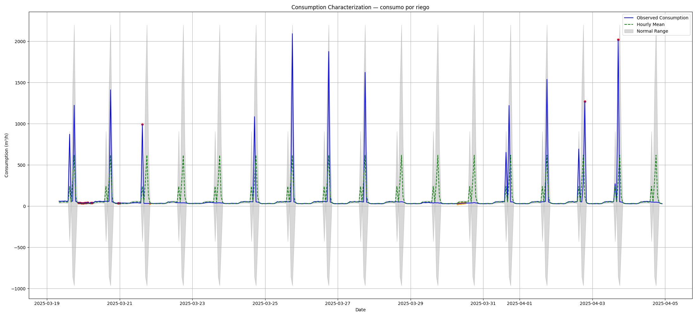

3. Deviation Heatmap
